TI 22 – 45. Technology Example – C-Kore Standalone TDR unit
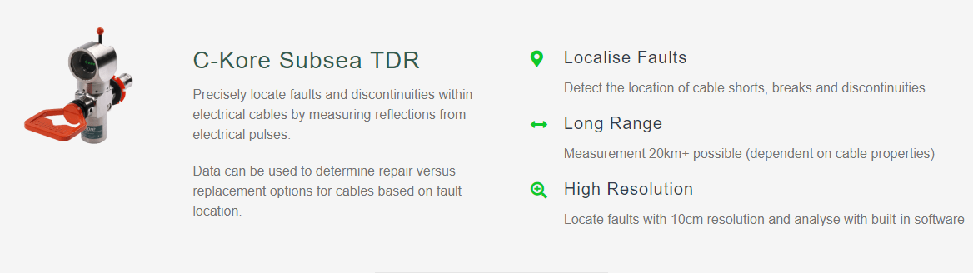
Manufacturers website:

Link: Subsea Fault-Finding - C-Kore: Simplify Subsea Testing

